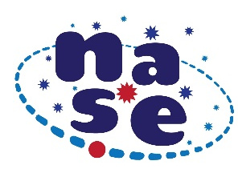
Herschel’s Experiment: descubrimiento del Infrarrojo (IR)

NASE's proposal is included in the International Day of Light, which commemorates the day when a human-created laser beam was lit for the first time. It is about repeating Herschel's experiment any day between March 21 to September 23, 2021, and filling the dates the table bellow:

Center where the experience takes place
Place and country
Latitude and longitude
Day, month, start time and end time
 | Thermometer # 1 in the blue | Thermometer # 2 in the yellow | Thermometer # 3 beyond red | Thermometer # 4 in the shadow
After 1 minute
After 2 minutes
After 3 minutes
After 4 minutes
After 5 minutes

This table with the data and results, and 2 or 3 photos of the experiment, must be sent before September 23, 2021 to newsletter.nase@gmail.com
