Finally, send this sheet with the results and two or three photos of each Experience to newsletter.nase@gmail.com

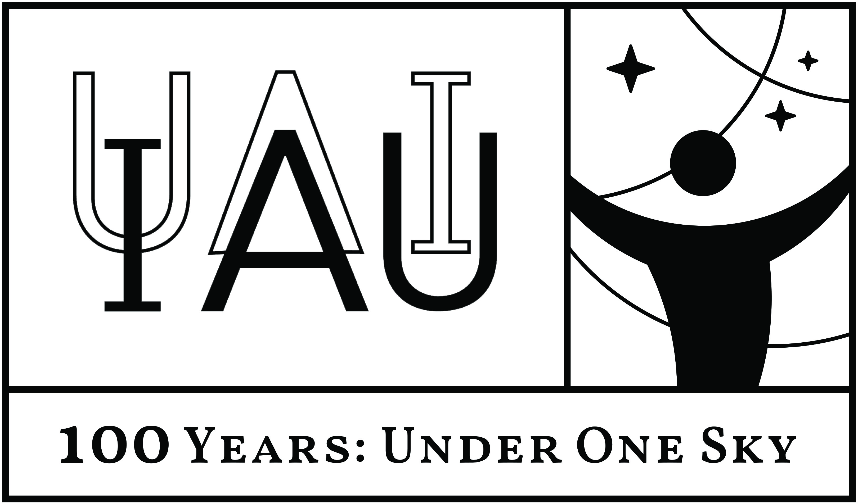 | 100 YEARS  INTERNACIONAL  ASTRONOMICAL  UNION  1919-2019 | 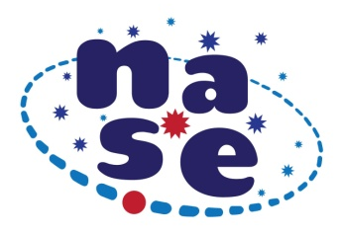

The power of the Sun and how to measure it

ACTIVITIES TO MAKE AND SEND

Perform the Experience 1 (with oil spot), the Experience 2 (with face cheek) or both, obtain the value for the Sun Power and record the results of each Experience in the following Results Table:
Table of Solar Power experiments results
Teacher’s name
School, Country
Day and hour
Type of Measurement | Patron |  | Results
Experiment 1:  Oil spot | Type of bulb | Indicated power  (W) | Distance  bulb-paper (m) | Calculated  Solar Power  (W)
Experiment 2:  Cheek of the face | Type of bulb | Indicated power  (W) | Distance  bulb-cheek (m) | Calculated  Solar Power  (W)

Project launch: March 21, 2019 (equinox)
The activity will be open until: June 21, 2019 (solstice)
The results will be disseminated worldwide under the initiative IAU100

