 | International  Day of Light:  The Parallel Earth and the Seasons  2020 | 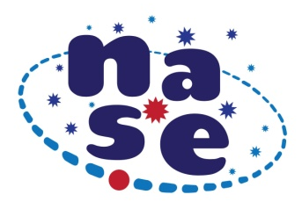

Parallel Earth to Watch the Season

ACTIVITIES TO CARRY OUT AND SEND
Perform the Parallel Earth Experience after reading the description of the proposal and submit Table 1 completed with the acquired data and one or more attached images of the experience. If you wish, also send a photograph of a solar clock made by your students.

Table 1. Parallel Earth Data
Teacher's name
email
School
City, Country
Latitude, Longitude
Day and hour

Note: it is very important that the photographs correspond to the place, day and time mentioned in Table 1

Optional: to complete the experience, those professors and students who wish may send photographs of a solar clock made by them.

Project launch: March 20, 2020 (equinox)
The activity will be open until: September 23, 2020 (equinox)
The results are framed within the initiative of the International Day of Light

