**Light, Cameras and Life**

Beatriz García, Rosa M. Ros, Ricardo Moreno, Pilar Orozco, Juan A. Prieto and Ivo Jokin

 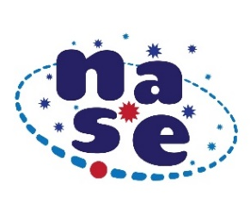 

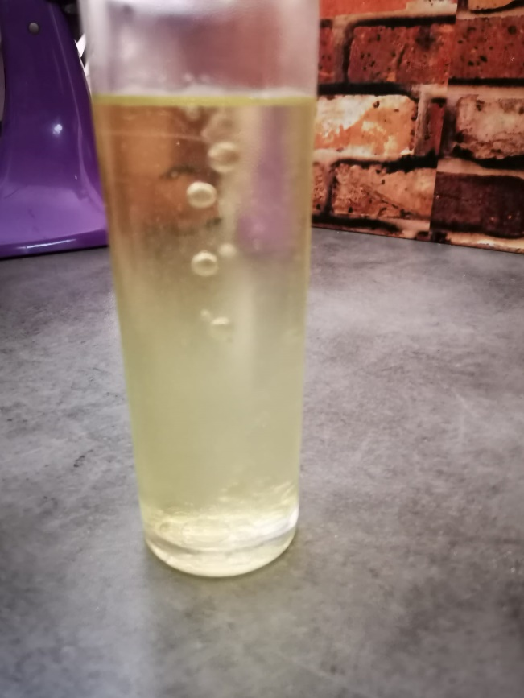 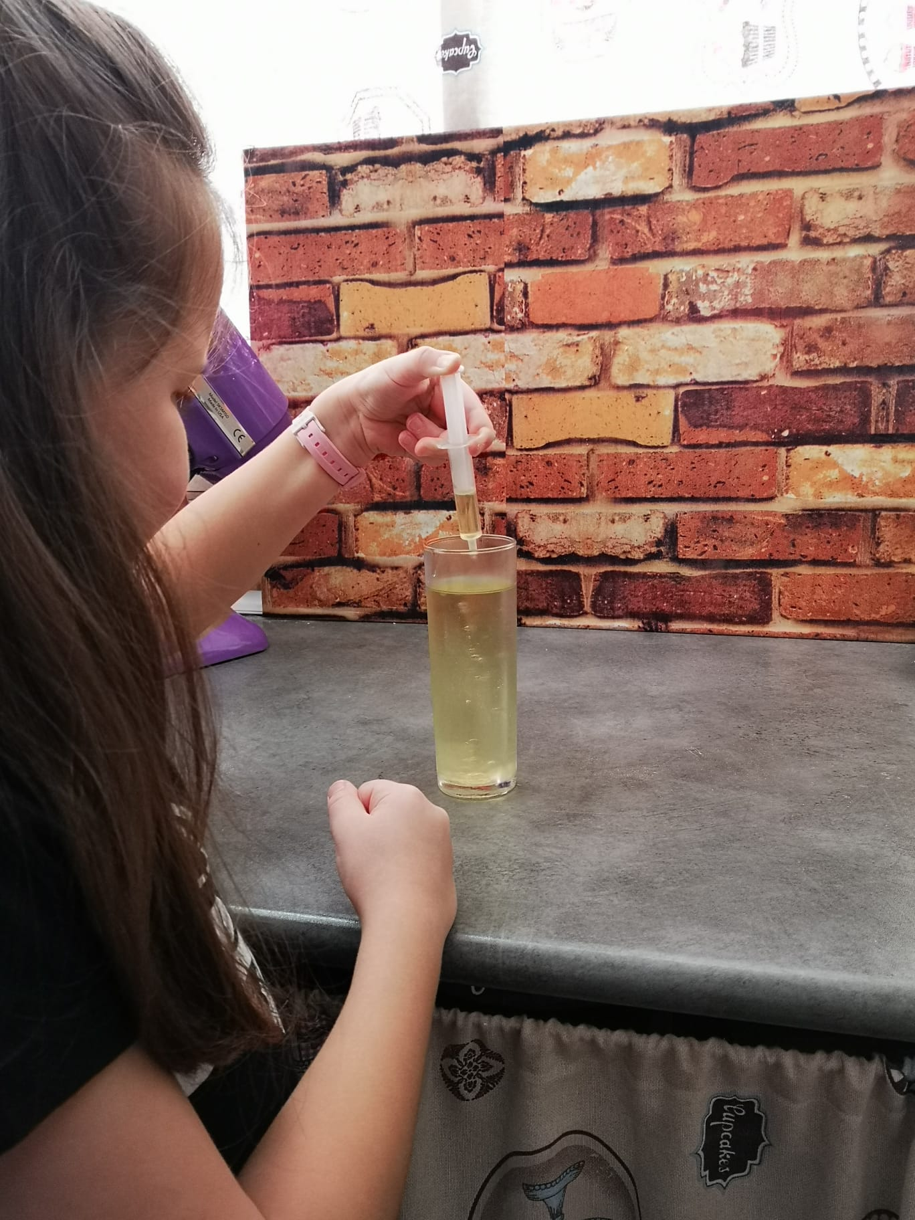

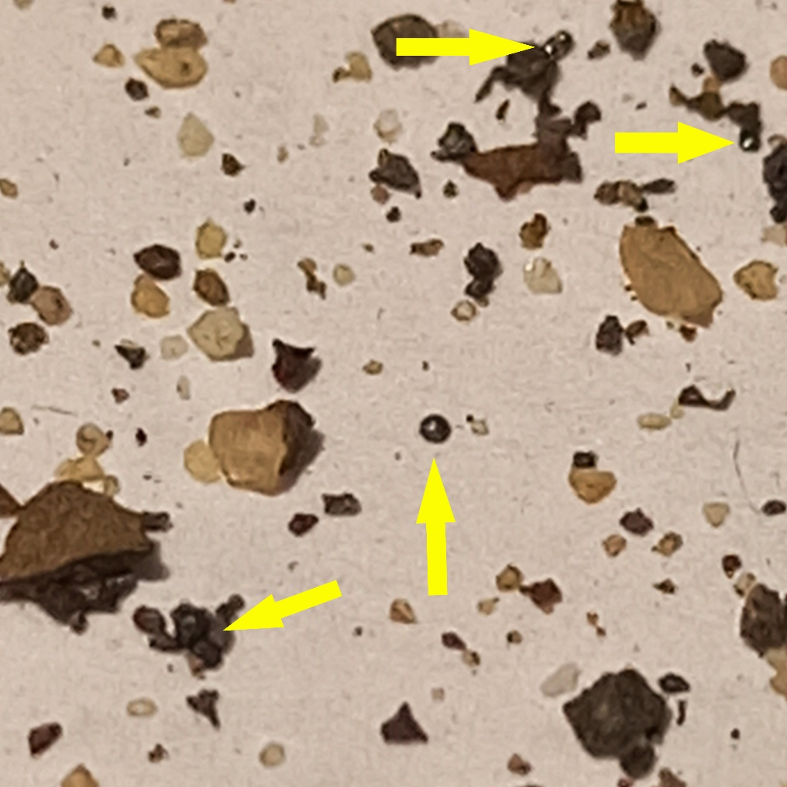

NASE's proposal within the International Day of Light consists in Introducing Astrobiology in Schools by means of an activity based in Looking for micrometeorites any day between March 20 and September 23, 2023, sending the results to[**newsletter.nase@gmail.com**](mailto:newsletter.nase@gmail.com)

**Micrometeorites: easy-to-get extraterrestrial material**

It is easy to collect micrometeorites, often suspended in the atmosphere for long periods of time and falling with different types of precipitation (such as rain or snow). These types of objects come directly from the matter that gave rise to the solar system, and therefore have an age of about 4,500 million years. The surprising thing is that and can be collected in a simple way.

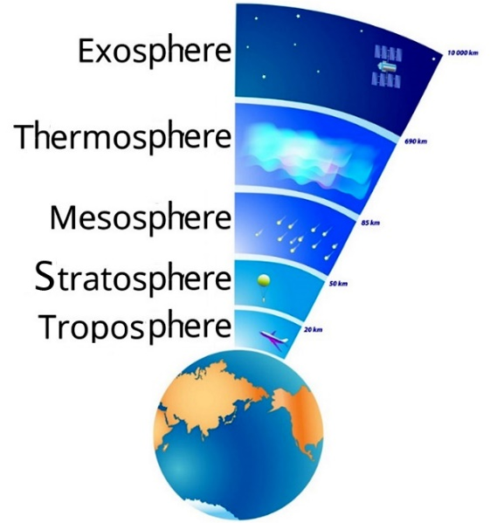

Fig. 1: Terrestrial atmosphere.

Meteors pass through the exosphere and thermosphere without difficulty because these layers are not very dense. But when they reach the mesosphere, the density is greater and when friction with the air occurs and heat is dissipated, the conditions are given for the material to melt and then solidify again in the stratosphere and troposphere, so that in the end it presents a spherical shape, sometimes with striations and sometimes small bubbles, the effect of rapid solidification.

Already on the surface of the Earth, those that are made of iron and nickel can be detected, separating them from other objects and rocks on the surface with the help of a magnet. However, in the soil there is a huge amount of ferromagnetic elements that remain trapped in the magnet, and separated from the rest of the small non-ferrous particles in the collected sample. Micrometeorites have a unique characteristic that allows them to be identified: they are spherical!

**Simulating Edible Micrometeorites**

To simulate (and understand) the way in which these objects, arriving from outer space, acquire their spherical shape, we propose a very simple procedure.

Heat 75 ml of chocolate milkshake or fruit juice in a saucepan and, before it comes to a boil, remove from heat and add 1 gram of agar-agar in the form of rain, thus preventing lumps from forming. Stir well and pass through a fine strainer.

Fill with very cold sunflower oil (before we will put it in the freezer for at least 30 minutes) a tall and transparent cylindrical container as a cooling column. With the aid of a syringe, drops of the heated liquid are dropped into the column of cold oil. The contrast of temperature and initial physical state of the smoothie or juice with agar-agar, cause small spheres to form immediately that accumulate solid at the bottom. Now we only have to drain the small spheres well.

MESOSFERA

***   ***

Fig. 2a: In a “casting effect” saucepan, Fig. 2b: Making the drip with a syringe, Fig. 2c: Column of cooling and condensation to form the spherifications and Fig. 2d: Final spheres.

If agar-agar is not available, the smoothie or juice with this substance can be replaced by gelatin. To obtain this jelly, you can cook 2 chicken legs in a little water (approximately a glass) for half an hour. The thick gelatin that is obtained acts in a similar way to the liquid thickened with agar-agar. With a syringe, the hot chicken gelatin is dropped into the oil. As the gelatin falls, it cools and solidifies into spherical balls.

**Looking for Micrometeorites in 3 steps**

1. **Collection**

1st method: Recovery of micrometeorites from material in gutters and road ditches.

The easiest and most recommended method to obtain micrometeorites consists of recovering the material that is continuously deposited on roofs, roads, etc. When it rains, the water washes them away, so a good place to collect micrometeorites is in the gutters on roofs and in the gutters of streets or routes, once they are dry. Simply, collect on a sheet of paper some sand that you find in those places.

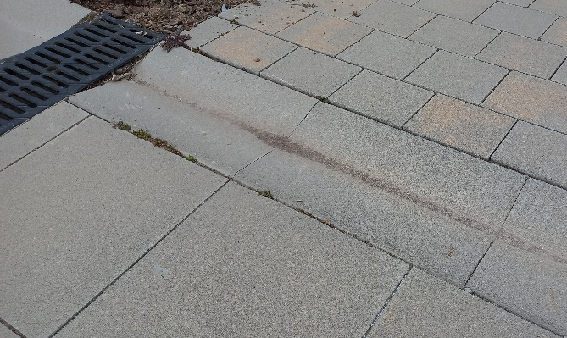 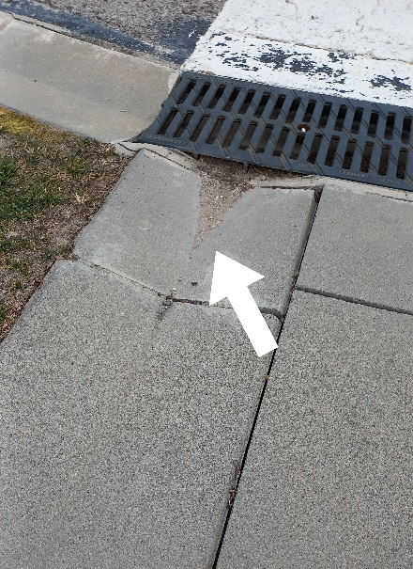

Fig. 3a: In the street you can find gutters or gutters where, after circulating the water, there is a sand where we can locate meteorites. Fig. 3b: We collect this grit with a piece of paper and proceed to analyze it.

2nd method: Construction of a general micrometeorite “trap”.

You can also build simple “traps”. For this you need the following items:

• a kitchen tray

• transparent cellophane paper (kitchen wrap)

Cover the tray with the cellophane by folding the edges or gluing the cellophane underneath to prevent it from blowing away (Figure 4).

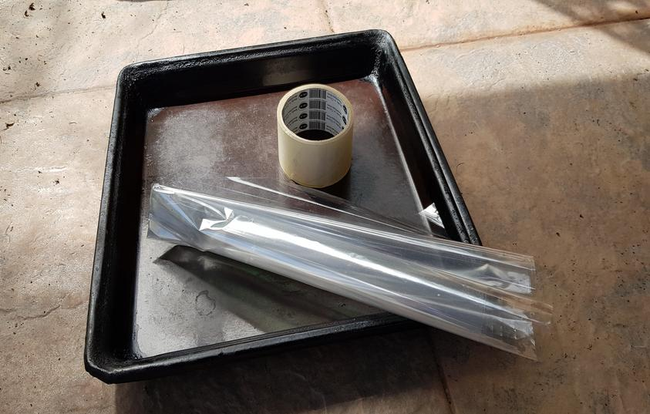 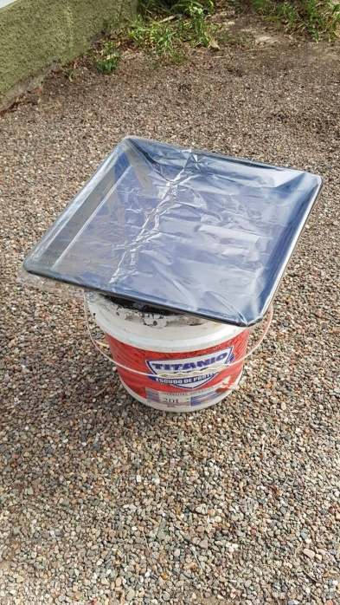 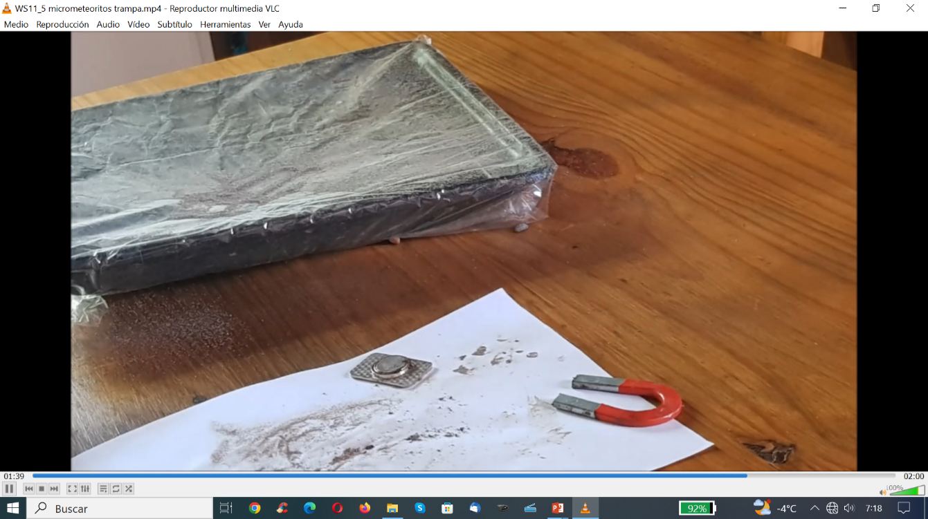

Fig. 4a: Tray, cellophane and tape, Fig. 4b: Micrometeorite “trap” set up in the garden during 2 days,

Fig. 4c: Transfer all the material accumulated.

Place the tray slightly off the ground, to prevent surrounding dust or the presence of animals from contaminating the sample (Figure 4b), in a place where there is not much wind and where nothing blocks the sky. Leave this setup outdoors for at least two days or a week. The paper will start to look “dirty”. At the end of the time, transfer all the material accumulated on the cellophane or film to a sheet of paper.

3rd method: Building an individual micrometeorite “trap”.

It is possible to prepare an individual trap for each student. It is necessary the following items:

• a paper cup

• a string for each cup

• a small magnet

In order to prepare the trap for each student we tied the cup with a string and we put a small magnet inside the cup. Students move around the schoolyard area with the magnet cups. Then remove the magnet and, if there are iron particles (micrometeorites), they will fall onto the white sheet of paper. Students observe with their phone cameras to find micrometeorites (they are small spheres).

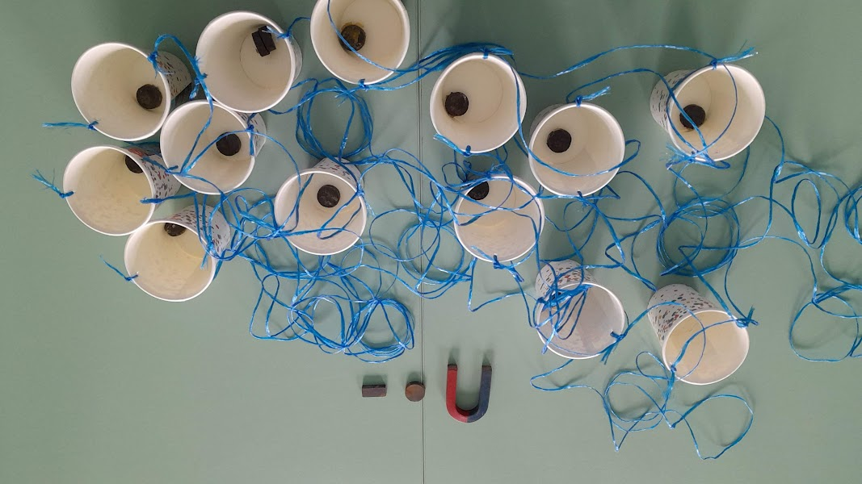 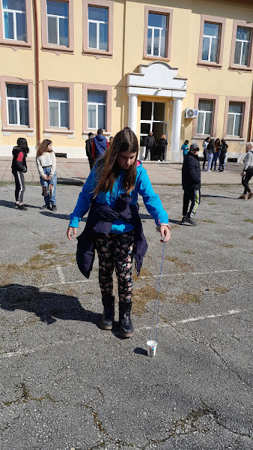 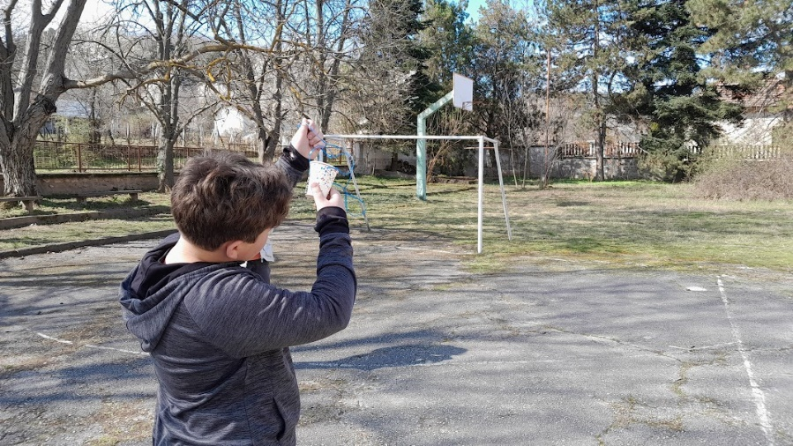

Fig. 5a: The cup tied with a string and a small magnet inside. Fig. 5b: Student using the cup. Fig. 5c: Looking for micrometeorites

1. **Separation and identification.**

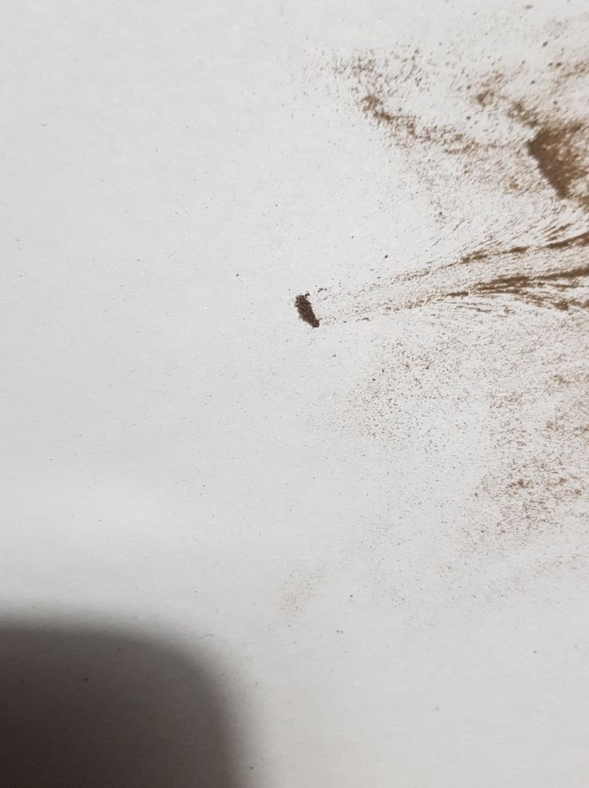In the first two cases, gutters/gutters or the trap, pass a magnet under the sheet of paper with the material: it will clearly be seen how small particles of ferrous material are attracted to the magnet (Figure 6). Without pulling the magnet apart, Flip the paper over, and all the sand will fall out, except those fine dark particles, which will be attracted to the magnet's magnetic field. Flip the paper over and remove the magnet. There may be possible micrometeorites there.

Fig. 6: The magnet, under the sheet of paper, drags the ferromagnetic material

When viewing the sample with a magnifying glass or the mobile phone camera at maximum zoom, the particles that are micrometeorites have signs of their previous fusion: they have spherical shapes, like small marbles.

If you want to increase the magnification of the mobile camera (Figure 7a and 7b), it is possible to put a drop of disinfectant gel (used during the COVID period) on the objective of the mobile camera, which acts as a magnifying glass. But the truth is that it is not necessary, with the mobile camera it is perfectly possible to distinguish whether they are spherical or not.

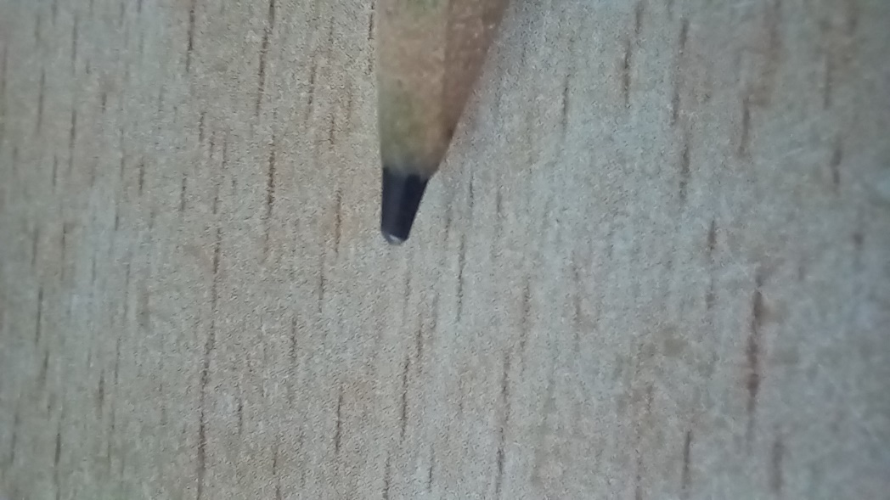 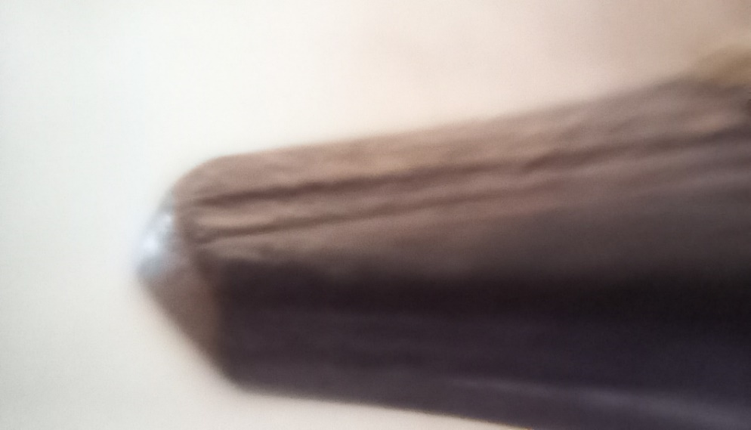

Fig. 7a: Photograph of a pencil lead with the mobile camera, Fig. 7b: Photograph of the lead using the drop of gel on the objective of the mobile or cell phone

1. **Research work**

After the separation and identification of the different micrometeorites in the sample, the record is achieved by acquiring photos with the cell phone, using the maximum possible magnification. This activity is already an important step in the framework of the proposal, because the participants are verifying the concepts shared at the beginning of it.

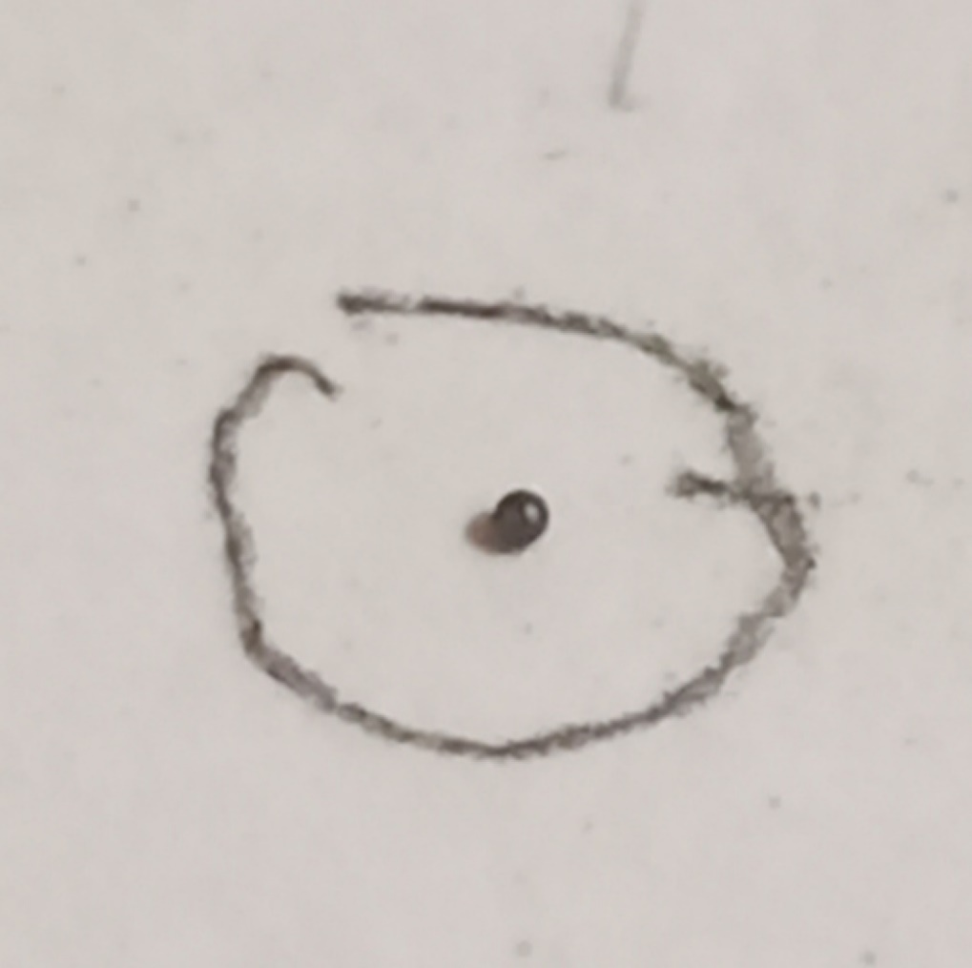 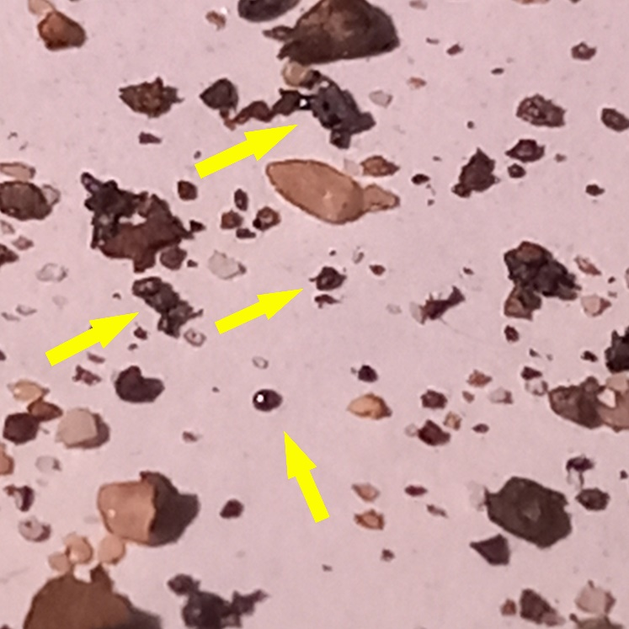

Fig. 8a: Photograph of a single isolated micrometeorite with the same camera, Fig. 8b: Photograph with several micrometeorites using the mobile camera.

On the other hand, the research work can be completed, trying to classify the micrometeorites by their morphology, differentiating their shape (not all of them are perfectly spherical, some are fused with others, etc. and produce a "gallery" of micrometerites detected by the group that participates in the project. It is proposed to share these discoveries, sending photographs of different detected micrometeorites, both individual and those that it was possible to classify according to their morphology.

|  |  |  |  |
| --- | --- | --- | --- |
| **Place: city, country** | **day month year** | **Number of micrometeorites** | **Is there any special morphology** |
|  |  |  |  |

Table 1: Collection of micrometeorites

In addition to the gallery of micrometeorites obtained, it is good to also send some photographs of the students collecting the micrometeorites and/or the experiment to perform spherifications.

**Conclusions**

This experience gives the possibility of obtaining extraterrestrial material that is always attractive to students. The procedure is simple and a significant number of micrometeorites can be obtained in a single intervention.

It can be interesting, in order to expand knowledge on the subject, to motivate students to investigate whether a meteorite has been found in their area and learn about its history, which can sometimes be quite curious... especially in cases of meteorites found a long time ago. many years. If possible, it is well worth visiting a museum or university that has some meteorites on display. Surely all this will increase interest in the subject.

We invite you to investigate and discuss this experience between teachers and students and send the results and conclusions to: [newsletter.nase@gmail.com](mailto:newsletter.nase@gmail.com)

**Bibliography**

* On the Trail of Stardust: The Guide to Finding Micrometeorites: Tools, Techniques, and Identification, Jon Larsen, Voyageur Press, Beverly, MA (USA), 2019.
* Experimentos para todas las edades, 3ª Edición. R, Moreno, Editorial Rialp, Madrid (España) 2022.
* **14 pasos hacia el Universo, 2ª. Edición. Ed. Rosa M. Ros & Beatriz García, Editorial Antares, Barcelona, 2018**
* <https://inta.es/descubre-y-aprende/es/3-2-1-Accion/Astronomia/micrometeoritos/>
* <https://www.astrogranada.org/single-post/2020/04/05/micrometeoritos>
* <https://www.sciencefriday.com/articles/up-on-the-roof-a-handful-of-urban-stardust/>
* <https://micro-meteorites.com/>
* <https://www.astrogc.com/index-otros-projects-met.html>
* <https://www.pbslearningmedia.org/resource/5762943c-af62-4a3b-8340-36660545628a/go-outside-and-play-micrometeorites-young-explorers/>

****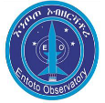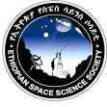**C:\Users\THINKP~1\AppData\Local\Temp\SEA_logo.jpg**

