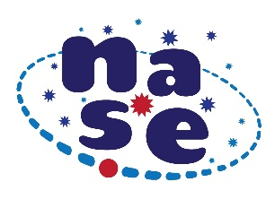
Looking for Micrometeorites

To recognize meteorites you have to select with a magnet the small spheres of iron and lithium that fall from the sky. Record your results and send us some photos of your micrometeorites and your work including your data in the following table.
Teacher's name

Center where the experience takes place

City and country | Latitude
Day, month, hour | Approximate size

This table with the data, photos of the micrometeorites found and 2 or 3 photos looking for micrometeorites, must be sent before September 23, 2023 to newsletter.nase@gmail.com
