 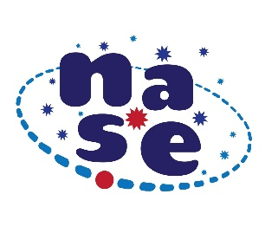

**“Messier Challenge”**

To observe one of the proposed objects with the naked eye with binoculars or a telescope if available. Explain what the observed object is, what impression you received when observing and send us a drawing or a photo of the object as well as some photos of the students preparing and carrying out the observation.

|  |  |  |
| --- | --- | --- |
| **Teacher's name** | | |
| **Student's names** | | |
| **Name of the observed object/s** | | |
| **Center where the experience takes place** | | |
| **City and country** | **Day, month, time** | **Latitude** |

**This table with the data, drawing or photos of the observed object and 2 or 3 photos preparing and carrying out the observation, must be sent before September 23, 2024 to** [**newsletter.nase@gmail.com**](mailto:newsletter.nase@gmail.com)

****

****

C:\Users\THINKP~1\AppData\Local\Temp\SEA_logo.jpg